Implement Stack using Queues

The problem is opposite of [this](https://tutorialspoint.dev/slugresolver/queue-using-stacks/)post. We are given a Queue data structure that supports standard operations like enqueue() and dequeue(). We need to implement a Stack data structure using only instances of Queue and queue operations allowed on the instances.

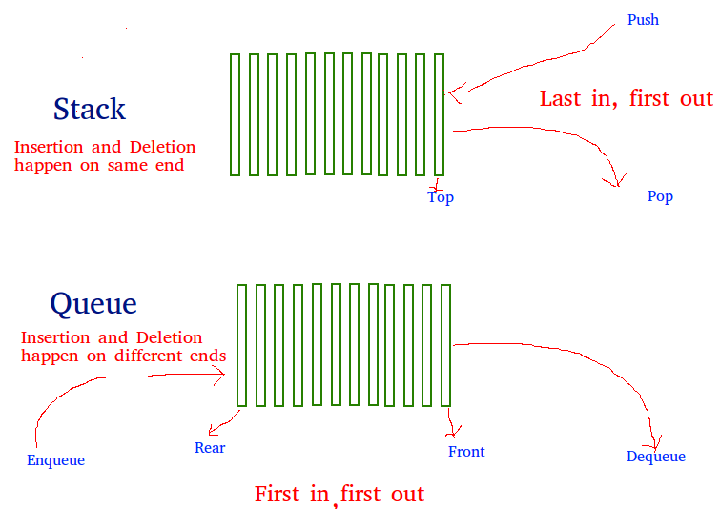

A stack can be implemented using two queues. Let stack to be implemented be ‘s’ and queues used to implement be ‘q1’ and ‘q2’. Stack ‘s’ can be implemented in two ways:

**Method 1 (By making push operation costly)**  
This method makes sure that newly entered element is always at the front of ‘q1’, so that pop operation just dequeues from ‘q1’. ‘q2’ is used to put every new element at front of ‘q1’.

push(s, x) // x is the element to be pushed and s is stack

1) Enqueue x to q2

2) One by one dequeue everything from q1 and enqueue to q2.

3) Swap the names of q1 and q2

// Swapping of names is done to avoid one more movement of all elements

// from q2 to q1.

pop(s)

1) Dequeue an item from q1 and return it.

**C++**

|  |
| --- |
| /* Program to implement a stack using  two queue */  #include<bits/stdc++.h>    **using** **namespace** std;    **class** Stack  {      // Two inbuilt queues      queue<**int**> q1, q2;        // To maintain current number of      // elements  **int** curr_size;    **public**:      Stack()      {          curr_size = 0;      }    **void** push(**int** x)      {          curr_size++;            // Push x first in empty q2          q2.push(x);            // Push all the remaining          // elements in q1 to q2.  **while** (!q1.empty())          {              q2.push(q1.front());              q1.pop();          }            // swap the names of two queues          queue<**int**> q = q1;          q1 = q2;          q2 = q;      }    **void** pop(){            // if no elements are there in q1  **if** (q1.empty())  **return** ;          q1.pop();          curr_size--;      }    **int** top()      {  **if** (q1.empty())  **return** -1;  **return** q1.front();      }    **int** size()      {  **return** curr_size;      }  };    // driver code  **int** main()  {      Stack s;      s.push(1);      s.push(2);      s.push(3);        cout << "current size: " << s.size()           << endl;      cout << s.top() << endl;      s.pop();      cout << s.top() << endl;      s.pop();      cout << s.top() << endl;        cout << "current size: " << s.size()           << endl;  **return** 0;  } |

**Java**

|  |
| --- |
| /* Java Program to implement a stack using  two queue */  **import** java.util.*;    **class** GfG {    **static** **class** Stack  {      // Two inbuilt queues  **static** Queue<Integer> q1 = **new** LinkedList<Integer>();  **static** Queue<Integer> q2 = **new** LinkedList<Integer>();        // To maintain current number of      // elements  **static** **int** curr_size;        Stack()      {          curr_size = 0;      }    **static** **void** push(**int** x)      {          curr_size++;            // Push x first in empty q2          q2.add(x);            // Push all the remaining          // elements in q1 to q2.  **while** (!q1.isEmpty())          {              q2.add(q1.peek());              q1.remove();          }            // swap the names of two queues          Queue<Integer> q = q1;          q1 = q2;          q2 = q;      }    **static** **void** pop(){            // if no elements are there in q1  **if** (q1.isEmpty())  **return** ;          q1.remove();          curr_size--;      }    **static** **int** top()      {  **if** (q1.isEmpty())  **return** -1;  **return** q1.peek();      }    **static** **int** size()      {  **return** curr_size;      }  };    // driver code  **public** **static** **void** main(String[] args)  {      Stack s = **new** Stack();      s.push(1);      s.push(2);      s.push(3);        System.out.println("current size: " + s.size());      System.out.println(s.top());      s.pop();      System.out.println(s.top());      s.pop();      System.out.println(s.top());        System.out.println("current size: " + s.size());  }  } |

**Python3**

# Program to implement a stack using  
# two queue  
from queue import Queue

class Stack:

def __init__(self):

# Two inbuilt queues  
self.q1 = Queue()  
self.q2 = Queue()

# To maintain current number  
# of elements  
self.curr_size = 0

def push(self, x):  
self.curr_size += 1

# Push x first in empty q2  
self.q2.put(x)

# Push all the remaining  
# elements in q1 to q2.  
while (not self.q1.empty()):  
self.q2.put(self.q1.queue[0])  
self.q1.get()

# swap the names of two queues  
self.q = self.q1  
self.q1 = self.q2  
self.q2 = self.q

def pop(self):

# if no elements are there in q1  
if (self.q1.empty()):  
return  
self.q1.get()  
self.curr_size -= 1

def top(self):  
if (self.q1.empty()):  
return -1  
return self.q1.queue[0]

def size(self):  
return self.curr_size

# Driver Code  
if __name__ == ‘__main__’:  
s = Stack()  
s.push(1)  
s.push(2)  
s.push(3)

print(“current size: “, s.size())  
print(s.top())  
s.pop()  
print(s.top())  
s.pop()  
print(s.top())

print(“current size: “, s.size())

**C#**

|  |
| --- |
| /* C# Program to implement a stack using  two queue */  **using** System;  **using** System.Collections;    **class** GfG  {    **public** **class** Stack  {      // Two inbuilt queues  **public** Queue q1 = **new** Queue();  **public** Queue q2 = **new** Queue();        // To maintain current number of      // elements  **public** **int** curr_size;    **public** Stack()      {          curr_size = 0;      }    **public** **void** push(**int** x)      {          curr_size++;            // Push x first in empty q2          q2.Enqueue(x);            // Push all the remaining          // elements in q1 to q2.  **while** (q1.Count > 0)          {              q2.Enqueue(q1.Peek());              q1.Dequeue();          }            // swap the names of two queues          Queue q = q1;          q1 = q2;          q2 = q;      }    **public** **void** pop()      {            // if no elements are there in q1  **if** (q1.Count == 0)  **return** ;          q1.Dequeue();          curr_size--;      }    **public** **int** top()      {  **if** (q1.Count == 0)  **return** -1;  **return** (**int**)q1.Peek();      }    **public** **int** size()      {  **return** curr_size;      }  };    // Driver code  **public** **static** **void** Main(String []args)  {      Stack s = **new** Stack();      s.push(1);      s.push(2);      s.push(3);      Console.WriteLine("current size: " + s.size());      Console.WriteLine(s.top());      s.pop();      Console.WriteLine(s.top());      s.pop();      Console.WriteLine(s.top());      Console.WriteLine("current size: " + s.size());  }  } |

**Output :**

current size: 3

3

2

1

current size: 1

**Method 2 (By making pop operation costly)**  
In push operation, the new element is always enqueued to q1. In pop() operation, if q2 is empty then all the elements except the last, are moved to q2. Finally the last element is dequeued from q1 and returned.

push(s, x)

1) Enqueue x to q1 (assuming size of q1 is unlimited).

pop(s)

1) One by one dequeue everything except the last element from q1 and enqueue to q2.

2) Dequeue the last item of q1, the dequeued item is result, store it.

3) Swap the names of q1 and q2

4) Return the item stored in step 2.

// Swapping of names is done to avoid one more movement of all elements

// from q2 to q1.

|  |
| --- |
| /* Program to implement a stack  using two queue */  #include<bits/stdc++.h>  **using** **namespace** std;    **class** Stack  {      queue<**int**> q1, q2;  **int** curr_size;    **public**:      Stack()      {          curr_size = 0;      }    **void** pop()      {  **if** (q1.empty())  **return**;            // Leave one element in q1 and          // push others in q2.  **while** (q1.size() != 1)          {              q2.push(q1.front());              q1.pop();          }            // Pop the only left element          // from q1          q1.pop();          curr_size--;            // swap the names of two queues          queue<**int**> q = q1;          q1 = q2;          q2 = q;      }    **void** push(**int** x)      {          q1.push(x);          curr_size++;      }    **int** top()      {  **if** (q1.empty())  **return** -1;    **while**( q1.size() != 1 )          {             q2.push(q1.front());             q1.pop();          }            // last pushed element  **int** temp = q1.front();            // to empty the auxiliary queue after          // last operation          q1.pop();            // push last element to q2          q2.push(temp);            // swap the two queues names          queue<**int**> q = q1;          q1 = q2;          q2 = q;  **return** temp;      }    **int** size()      {  **return** curr_size;      }  };    // Driver code  **int** main()  {      Stack s;      s.push(1);      s.push(2);      s.push(3);      s.push(4);        cout << "current size: " << s.size()           << endl;      cout << s.top() << endl;      s.pop();      cout << s.top() << endl;      s.pop();      cout << s.top() << endl;      cout << "current size: " << s.size()           << endl;  **return** 0;  } |

**Output :**

current size: 4

4

3

2

current size: 2